**Topics: Descriptive Statistics and Probability**

1. Look at the data given below. Plot the data, find the outliers and find out $μ, σ, σ^{2}$

|  |  |
| --- | --- |
| **Name of company** | **Measure X** |
| Allied Signal | 24.23% |
| Bankers Trust | 25.53% |
| General Mills | 25.41% |
| ITT Industries | 24.14% |
| J.P.Morgan & Co. | 29.62% |
| Lehman Brothers | 28.25% |
| Marriott | 25.81% |
| MCI | 24.39% |
| Merrill Lynch | 40.26% |
| Microsoft | 32.95% |
| Morgan Stanley | 91.36% |
| Sun Microsystems | 25.99% |
| Travelers | 39.42% |
| US Airways | 26.71% |
| Warner-Lambert | 35.00% |

Step 1- imported above table in ms excel and converted percentage values(Measure X) to the decimal (float) format. Saved data in set1.csv file.

Step 2- imported file to the Jupyter home.

Step 3-

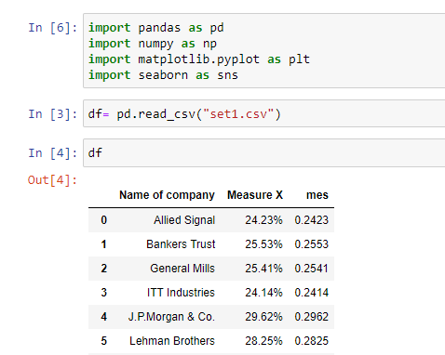

Step 4-

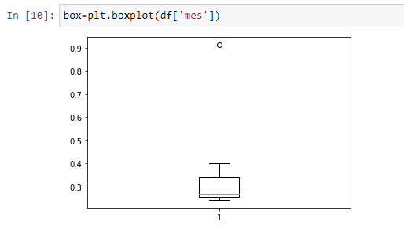

Step 5-

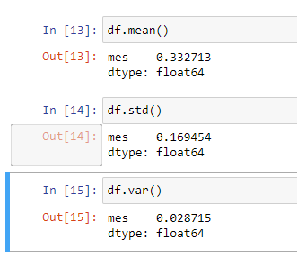



Answer the following three questions based on the box-plot above.

1. What is inter-quartile range of this dataset? (please approximate the numbers) In one line, explain what this value implies.

* Inter quartile range= 5 to 12

1. What can we say about the skewness of this dataset?

* Data is positively skewed.

1. If it was found that the data point with the value 25 is actually 2.5, how would the new box-plot be affected?

* It will not affect as much cause value 2.5 is slightly negligible than other values which are having more frequency.
* Median will be as it is.



Answer the following three questions based on the histogram above.

1. Where would the mode of this dataset lie?

* Between 4 and 10 of values y

1. Comment on the skewness of the dataset.

* Data is positively skewed.

1. Suppose that the above histogram and the box-plot in question 2 are plotted for the same dataset. Explain how these graphs complement each other in providing information about any dataset.

* The median of boxplot is at 6.
* In histogram point 5 & 6 having more frequency than other points.
* In both plots 25 is outliers which is clearly visible.
* Both plots are positively skewed.

1. AT&T was running commercials in 1990 aimed at luring back customers who had switched to one of the other long-distance phone service providers. One such commercial shows a businessman trying to reach Phoenix and mistakenly getting Fiji, where a half-naked native on a beach responds incomprehensibly in Polynesian. When asked about this advertisement, AT&T admitted that the portrayed incident did not actually take place but added that this was an enactment of something that “could happen.” Suppose that one in 200 long-distance telephone calls is misdirected. What is the probability that at least one in five attempted telephone calls reaches the wrong number? (Assume independence of attempts.)

* ANS- 0.024755

1. Returns on a certain business venture, to the nearest $1,000, are known to follow the following probability distribution

|  |  |
| --- | --- |
| x | P(x) |
| -2,000 | 0.1 |
| -1,000 | 0.1 |
| 0 | 0.2 |
| 1000 | 0.2 |
| 2000 | 0.3 |
| 3000 | 0.1 |

1. What is the most likely monetary outcome of the business venture?

* $2000

1. Is the venture likely to be successful? Explain

* According to given data probability of positive numbers are more so we can say that it is successful.

1. What is the long-term average earning of business ventures of this kind? Explain

* In that case we say that the expected value of returns to this particular venture is the required average. $800

1. What is the good measure of the risk involved in a venture of this kind? Compute this measure